*Класс: 10*

*УМК: «Enjoy English 10» «Английский с удовольствием»*

*Авторы: Биболетова М.З.*

*Тема учебного занятия: “Clothes and Fashion. The school uniform”*

*Место урока в учебно- тематическом плане- Unit 1.*

*Продолжительность учебного занятия: 1 урока (40 минут)*

*Тип урока: повторительно- обобщающий*

*Задачи:*

1)расширение общего кругозора;  
2) Обобщение и активизация знаний по теме «Одежда и мода»  
3) Развитие умения участвовать в общении в связи с предъявленной ситуацией, выражать своё отношение к предмету разговора.

Цель урока:

- развивать мыслительную активность учащихся в процессе выполнения коммуникативных заданий;

- воспитывать культуру внешнего вида;

- учить разбираться в стилях и направлениях современной моды и высказывать своё мнение;

- развивать эмоционально-образную сферу и творческие способности учащихся;

- учить защищать мини-проекты.

*Оборудование:*

- компьютер,

- проектор,

-интерактивная доска.

*Оснащение:*

- видеоролик,

- презентации.

- фотографии или рисунки костюмов 20-го столетия, начала XXI, раздаточный материал.

-CD MP3

**I. Beginning.**

Teacher (T): Good morning, everybody! I'm glad to see you all here. Sit down, please! Who is on duty today? Who is absent?

P: I am on duty today. Everybody is present and we are ready for the lesson.

Т: Yesterday I bought a new magazine. Look at it. How do you think what it is about? And why have I brought it today?

* (Ch) It’s about clothes. It’s about famous designers.
* It’s about fashion…. And “fashion” is the topic of our lesson…

(T) Yes, you are right. Today we continue to speak about clothes, shopping and fashion in our life. The topic of our lesson is "Fashion We'll speak English a lot, read a quiz, do a crossword, read a text, answer the questions, watch presentations, listen to the tape, we'll see three mini-projects.

1.Revising the vocabulary

T: First of all, let us revise the vocabulary. Look at the interactive board.

**Мультимедиа 4 класс 5** юнит --------- индив. Зад. На ноутбуке??? (Шавкату)

С ОСТАЛЬНЫМИ НА УРОКЕ ------**Match the words and their translations**.

1. glamorous а) поношенный
2. colourful b) расклешенный
3. tight с) цветной, пестрый
4. flared d) мешковатый
5. baggy e) стильный
6. waterproof f) роскошный
7. worn g) водоотталкивающий
8. stylish h) облегающий

Key: 1f), 2с), 3h), 4b), 5d), 6g), 7а), 8e)

II.Follow-up

*Look at the screen and read two English proverbs. Which I more close to you? Why?*

**"Clothes make the man"**

**"Never judge a book by its cover"**

T: Well, let's go on. Clothes come in and go out. Clothes change with the time. Answer some questions, please. *Are clothes important to you?*

P1: Yes of course, that's very true.

P2: Clothes are important to me. I prefer casual clothes. I feel more comfortable in them. T: *Do you try to follow fashion?*

P3: As for me, yes, I do. Clothes are important because they tell people who you are.

P4: That's true. I care about fashion. My favourite pastime is to look through the latest magazines. I like to look round in the shops and find something peculiar.

T: *Do you feel uncomfortable in the company of better-dressed people?*

P5: I feel better if I know that I have good clothes on.

P6: I don't care about it. People spend too much money on clothes. I think it's stupid.

P7.I prefer comfy clothes. All I need is a pair of jeans. They always look cool. You can wear them with a T-shirt and trainers.

T: *Do clothes make the man?*

P7: I think clothes are a status thing. They say, "Clothes make the man" and I agree.

P8: I think, it's true. Clothes are a status thing.

III. The main part of lesson.

T: That's right. Fashion plays a great role in our life. Lots of teenagers think that their clothes are the most important thing about them. But I prefer, "Never judge a book by its cover"

2. T: The 1st group of pupils has prepared a small **video-film**. They asked some teens from our school for their opinion about clothes. Here are some of their answers. Let's see a video.

(Идет показ видеоролика, где учащиеся школы высказываются об одежде.

(Высказывания учащихся)

Pupil-correspondent - 1: Hello! My name is Oleg.

Pupil-correspondent 2: Hello! My name is Nastya.

P1.Teenagers are human, so of course they have problems. Clothes are one of them. We asked some teens from our school for their opinion about clothes. Here are some of their answers.

Pupil-correspondent2 *Are clothes important* *to you?*

P1: Hi! My name is .... I'm 16. Clothes are very, very important to me. They show my personality, they say who I am. It's the first thing people see when they meet me.

P2: Hi! My name is .... I'm 15.1 hate when girls talk about someone's clothes all the time. I think that who you are is more important than your clothes.

P-corr. 1: *Do you feel uncomfortable in the company of better dressed people?*

P3: Hello! I'm .... I think you feel better if you know you have good clothes on, anything with a reasonably good label.

P4: Hello! I'm I think that the most important thing is to feel comfortable. I always wear jeans and a T-shirt. They are cheap, cool and comfy.

P-corr.2: *Do you like to look through the latest magazine?*

P5: Oh, my clothes have to be the latest fashion and of course, I like to look through the latest magazines.

P-corr.1: *Do you try to follow fashion?*

P6: Morning. My name is Next year I'll be a school-leaver. Clothes make the man.People make up their mind about you, when they look at your clothes. So, my lothes have to be of the latest fashion.

P7: Hi! I'm ..., I don't care about fashion, I prefer casual clothes.

P-corr2: *Do you like shopping?*

P8: Sure, I like to look round the shop.

P-corr.: We've seen so many peoples, so many point of views. Tastes are differ. To my point of view, there are more important things in life than clothes. People are nice, even if they wear old shoe

T: Good for you. You have done great work. Thanks. Let's go on.

4.T: The 2nd group of pupils has prepared computer presentation with some information about the fashion of the 20th century. Let us look at the screen.

Группа учащихся представляет свою презентацию **«Fashion of the 20th century».**

T: Thanks for your mini-project. I think you’ve worked hard. We enjoyed your presentation very much. Thank you.

2 индив. Задания «Ода кедам» (Сергей) и «Определение словам» (Влад)

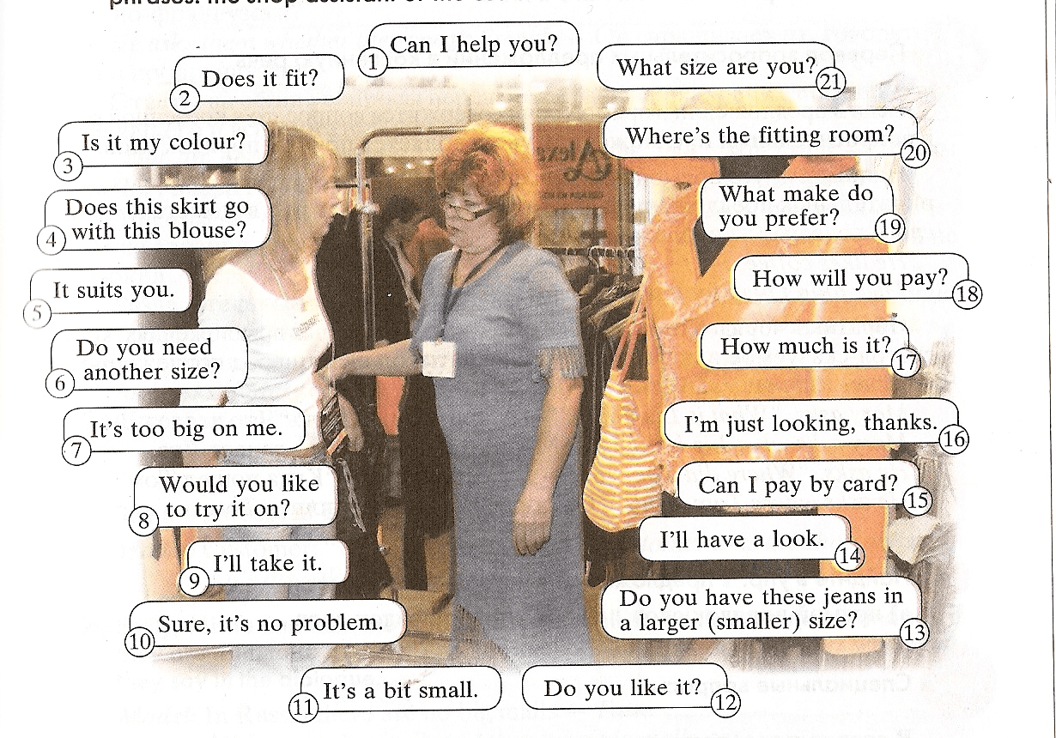

Диалог What size are you? **(Марго и Алик)(**Диана и Алексанян) поставить вешалку с одеждой

*T:I see fashion is important to you. You want to be attractive and your clothes must show your individuality .And one more question: Do you like shopping?*

*P1: Yes I do. I like shopping*

*P2: I don’t care about fashion but I like shopping*

3. Now let’s do eh.1,p.63

T.: Work in pairs. Make up and act dialogues. Use the phrases. In the shop

6.Relaxation.

Let’ relax a little bit.

Звучит музыка «Голоса природы» (пение птиц, шелест листьев, дуновение ветра)

T.: What a sweet music! Natural sounds are lovely indeed. Nature helps us to relax and dream a little bit. Close your eyes! Open your eyes! Look up! Look down! Turn left! Turn right! Hands up! Hands down! OK!

5. T: I have prepared a **crossword for you**. Please do it and you will find the name of the most popular clothes.

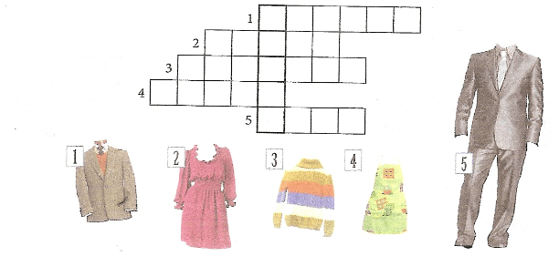

7. **Практика в аудировании**. Выполнение заданий. Самостоятельная работа.

J E A N S

**T:** What are the most popular clothes? **P:** Jeans are the most popular clothes.

**T:** Jeans are fashionable nowadays, everybody wears them — presidents, workers, students, pop stars... Jeans are cool, comfy and classless.

What is the secret of such popularity? You'll listen to a piece of information about jeans. But first, let's read the new words and their translation.

**T:** After listening to the text you are to make a short quiz. So listen attentively.

**Bavarian** — баварец

**miner** — шахтер

**in search of gold** — в поисках золота

**to be an immediate success** — сразу же стать популярным

**canvas** — парусина

**to stuff with tools and rocks** —

заполнять инструментами и камнями

**copper rivets** — медные заклепки

**Моя запись аудио!!!!!!!!!!!!!!!!**

*JEANS STORY*

*The Bavarian called Levi Strauss invented the first pair of jeans. He emigrated from Germany to San Francisco in 1850. At that time Levi Strauss was twenty years old and he had been a cloth seller in New York.*

*He decided to sell clothes to the miners who were in California in search of gold. A poor miner asked him for some durable trousers. The miner, the first person in the world who wears jeans, liked this cloth. Levi's jeans were an immediate success. They called it "denim" (from Nimes, a city in France). More and more miners were coming to Strauss asking him for a pair of those wonderful canvas trousers.*

*The only problem with denim was that it had no colour. The trousers didn't look very interesting, and they got dirty easily. Levi decided to dye the denim blue.*

*The jeans were strong everywhere, but weak on the pockets which miners used to stuff with tools and rocks. A Russian immigrant, named Jacob Davis, offered Strauss idea of using copper rivets to hold the pockets and the jeans together.*

*On 20 May 1873, Levi and Jacob patented their new kind of trousers. This day is considered to be the official 'birthday' of blue jeans.*

*Today, Levi Strauss & Go is known around the world. And jeans are recognized as the universal piece of clothing that has crossed over class, gender, age, and nationality. Long live jeans!*

Контроль понимания проходит через выполнение заданий викторины. Учащиеся получают карточки с викториной и выбирают правильные ответы.

**1**

**. Levi Strauss was**

1. American.
2. *German.*
3. Russian.

2. **He was a**

1. book seller.
2. tailor.
3. *cloth seller.*

3. **First jeans**

1. were blue.
2. *had no colour*.
3. were dirty.

**4. A Russian immigrant Jacob David offered Strauss idea of**

1. *using copper rivets.*
2. selling jeans.
3. fabel.

**5. Levi and Jacob patented their new kind of pants** in

1. *1873*.
2. 1883.
3. 1836.

*Answers:* lb), 2c), 3 b), 4a), 5a)

T: Now collect your cards. It's time to show the results of your work and present your answers. (После того как учитель собрал карточки с ответами, учащиеся озвучивают правильные ответы.)

8**. Практика в чтении**. Выполнение заданий. Самостоятельная работа.

T.Well, let’s continue our lesson. Styles are changing. Fashions come and go out. But T-shirts and jeans have the popularity all over the world.

Another story is about the origin of T-shirt. The text is divided into several parts. Put it into logical order.

*T- SHIRT*

*а) American troops (войска) copied the idea and started calling them "T-shirts" because of their T-shape. In the mid-1950s, rock star Elvis Presley shocked the world by wearing the T-shirt on TV.*

*b) By the 1960s, T-shirts had conquered (завоевали) the world. Sports teams, clubs and rock bands were all using colours and logos on their "tees" to be noticed.*

*c) T-shirts started as underwear (нижнее белье). During the First World War, European soldiers*

*wore them underneath (под) their uniforms to keep warm.*

*d) They tell others what we like, where we have been, the things we've done, the competitions*

*we've won.*

*е) Today, T-shirts are worn in every corner of the world. Babies, kids, teenag­ers and adults wear them.*

*T: Look at the screen and check yourself. Keys; c),a),b),e),d*

T: Now we are going to show you an unusual and beautiful collection of dresses made by our pupils. The designer of this collection is ………….(Девочки демонстрируют образцы модной одежды.)

T: Dear friends, our lesson is **almost over**. We've done a lot of work. What have we done at our lesson?

Ps: We have spoken English a lot, done a quiz and a crossword, read a text, answered the questions, watched presentations, listened to the tape.

T: Which part of the lesson did you like most of all?

P1: I liked the fashion show.

T: What emotions do you feel?

P1: It is important to know about styles of fashion and clothes for different events in our life.

P2: I agree with you, but there are more important things in life than clothes

T: Thank you for the lesson, you were very active, attentive and bright. I enjoyed your work at the lesson. Your marks are...

Your homework: Do the test "Are you a fashion victim?" and find out it..

Now the lesson is over. Goodbye